Sam Lee

3/17/18

CPE 64

Professor Kiran

Lab Report #2

Part 1A:

In this part of part 1, I watched a YouTube video to learn how to use the IDE for Verilog called Quartus Prime. In this video it taught me how to start a project, new file, compile, and run the program in the FPGA board. To start writing Verilog code I had to first set up the IDE and then I can start programming. To start a Verilog code you will have to name is module …(in1, in2, out), write the inputs and outputs, and write endmodule to finished the code. After you finish writing the code, you’ll have to compile it and check for any errors, and if it has no errors then I click the programmer button in the IDE. The programmer allows the code to get in the FPGA board and I can test the code through the board.

Part1B:

For this part of the lab I had to program an AND, OR, NAND, and NOT Gate in Verilog. I had to take the predicted and observed results and then compare the results to their truth tables to see if the results held true to their function.

AND Gate:

\*a detailed description an AND Gate

Verilog Code:

module ANDGate(in1, in2, out);

input in1, in2;

output out;

wire in1, in2, out;

and g1(out, in1, in2);

endmodule

Observed and Predicted Results:

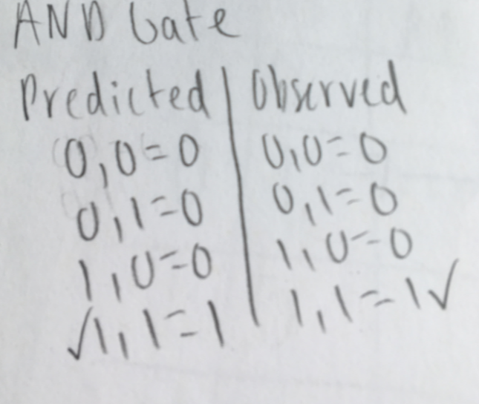

Quartus Prime and Amani Board:

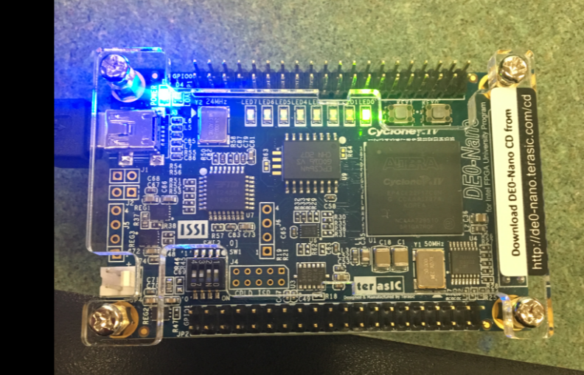

\*Input 1,1 and Output 1

NAND Gate:

\*a detailed description a NAND Gate

Verilog Code:

module NANDGate(in1, in2, out);

input in1, in2;

output out;

wire in1, in2, out;

nand g1(out, in1, in2);

endmodule

Observed and Predicted Results:

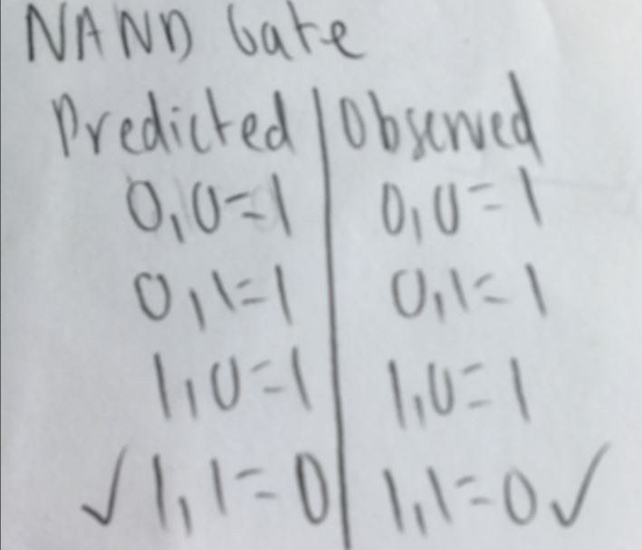

Quartus Prime and Amani Board:

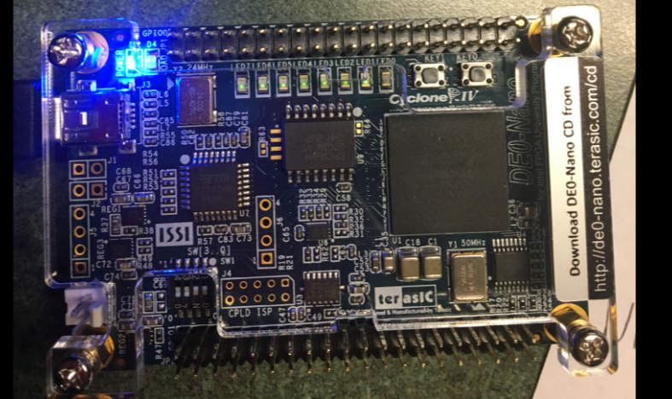

\*Input 1,1 and Output 0

NOT Gate:

\*a detailed description a NOT Gate

Verilog Code:

module NOTGate(in1, out);

input in1;

output out;

wire in1, out;

not g1(out, in1);

endmodule

Observed and Predicted Results:

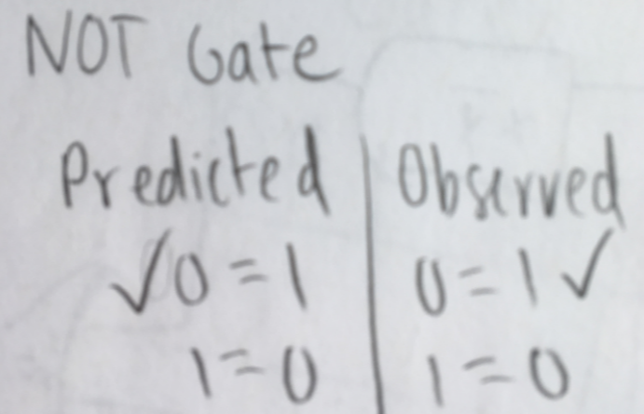

Quartus Prime and Amani Board:

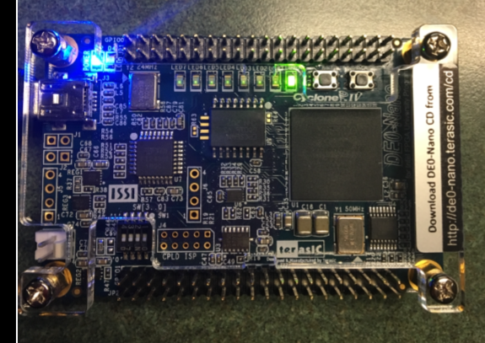

\*Input 0 and Output 1

OR Gate:

\*a detailed description an OR Gate

Verilog Code For OR Gate:

module ORGate(in1, in2, out);

input in1, in2;

output out;

wire in1, in2, out;

or g1(out, in1, in2);

endmodule

Observed and Predicted Results:

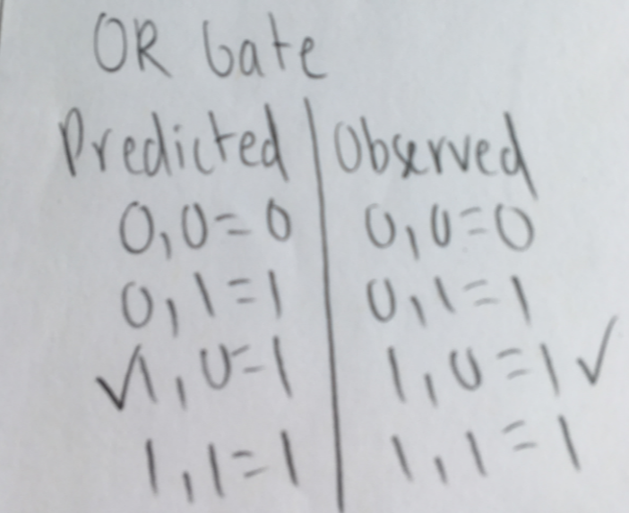

Quartus Prime and Amani Board:

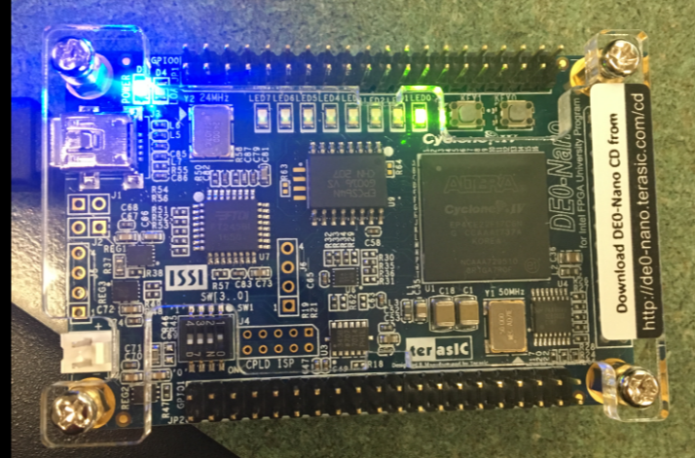

\*Input 1,0 and Output 1

All Four Gates:

\*a detailed description of all four gates c

Verilog Code:

module AllFourGates(in1, in2, out, out1, out2, out3);

input in1, in2;

output out, out1, out2, out3;

wire in1, in2, out, out1, out2, out3;

and g1(out, in1, in2);

or g2(out1, in1, in2);

nand g3(out2, in1, in2);

not g4(out3, in1);

endmodule

Observed and Predicted Results:

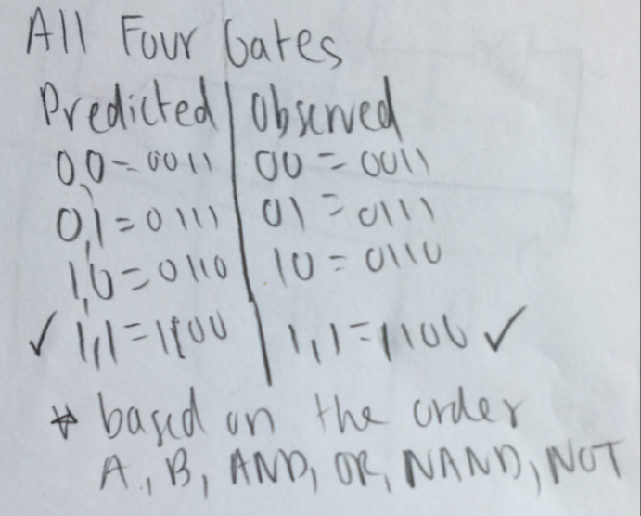

Quartus Prime and Amani Board:

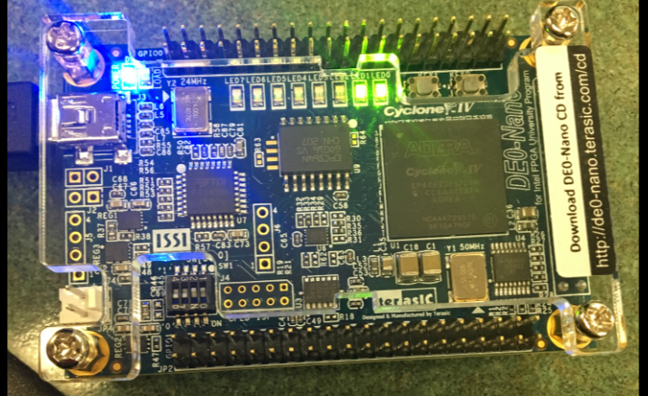

\*Input 1,1 and Output 1,1,0,0

Part 2:

In this part of the lab, I learn what an Exclusive OR is and its function. I had to verify if the diagram and FPGA board match with the truth table. I had to draw its circuit diagram on paper with its proper internal nodes, inputs, and outputs.

Exclusive OR Gate:

\*a detailed description an Exclusive OR Gate

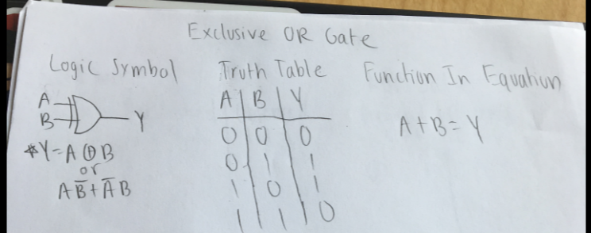

Verilog Code:

module ExclusiveOrGate(in1, in2, out);

input in1, in2;

output out;

wire in1, in2, out;

wire notin1out, notin2out, and1out, and2out;

or or1(out, and1out, and2out);

and and1(and1out, in1, notin2out),

and2(and2out, in2, notin1out);

not notin1(notin1out, in1),

notin2(notin2out, in2);

endmodule

Drawing:

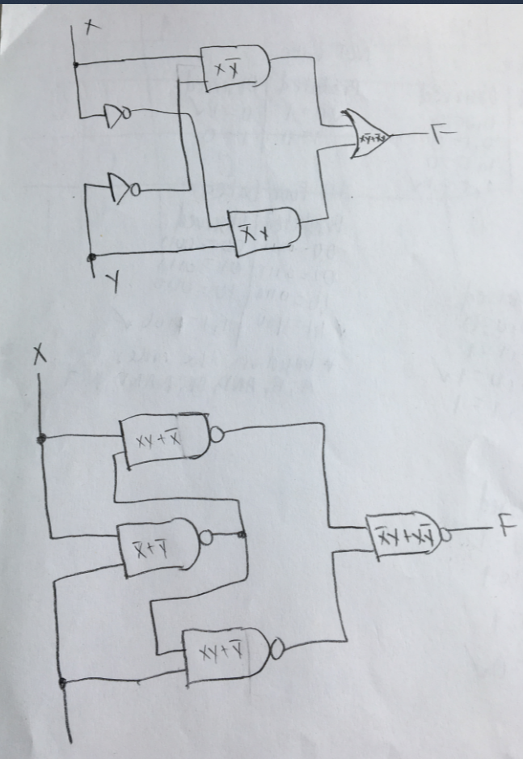

Quartus Prime and Amani Board:

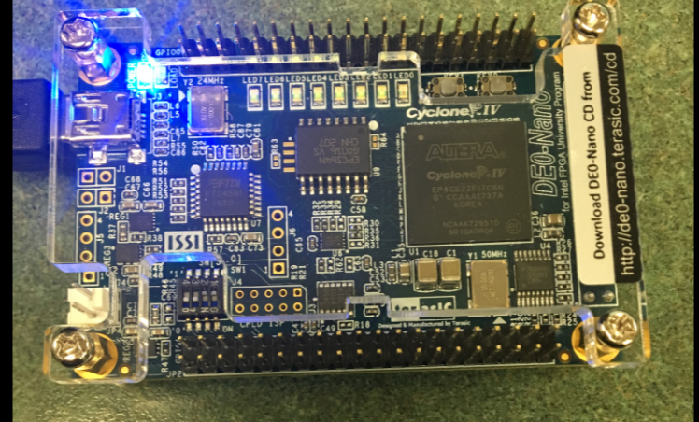

\*Input 1,1 and Output 0

Second Exclusive OR Gate:

\*a detailed description of the Second Exclusive OR Gate

Verilog Code:

module SecondExclusiveOrGate(in1, in2, out);

input in1, in2;

output out;

wire in1, in2, out;

wire nand1out, nand2out, nand3out;

nand nand4(out, nand1out, nand3out);

nand nand3(nand3out, nand2out, in1);

nand nand2(nand2out, in1, in2);

nand nand1(nand1out, in2, nand2out);

endmodule

Quartus Prime and Amani Board:

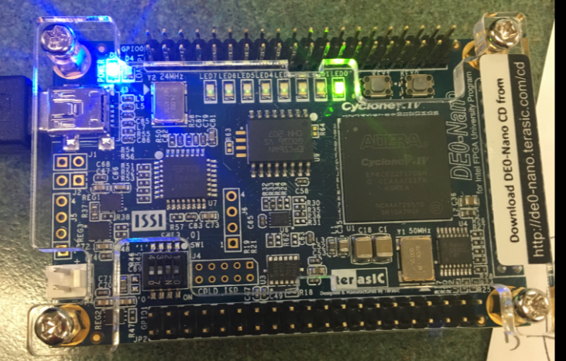

\*Input 0,1 and Output 1

Part 3:

In this part of the lab, I had to solve the function given to me in this lab by using Boolean algebra and then creating a K-map from it in order to verify my results. From my results I created I truth table by using binary for inputs A, B, C, and D and F as my output. In total I had 5 output combinations for the binary number for 3, 7, 9, 11, and 15. Then I created a schematic on Multisim and tested my truth table. After I had verified that my schematic was correct I used it as reference when creating the Verilog code for it. I had made sure that my code compiled and programmed successfully onto the FPGA. Then I made sure my FPGA was giving me the correct output by referring to my truth table. One key thing when I was programming was to make sure my pin assignments were correct or else I wouldn’t get the correct output.

\*a detailed description of the Part 3 Design

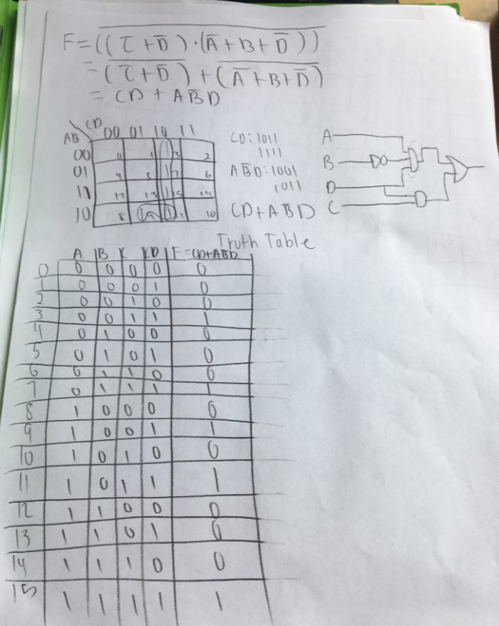

\*the Truth Table, simplified equation, and K-Map for Part 3

Verilog Code:

module Part3Design(in1, in2, in3, in4, out);

input in1, in2, in3, in4;

output out;

wire in1, in2, in3, in4, out;

wire not1out, orout, and1out, and2out, and3out;

and and1(and1out, not1out, in1);

and and2(and2out, in4, and1out);

and and3(and3out, in3, in4);

not not1(not1out, in2);

or or1(out, orout, and2out, and3out);

endmodule

Schematic Circuit Design:

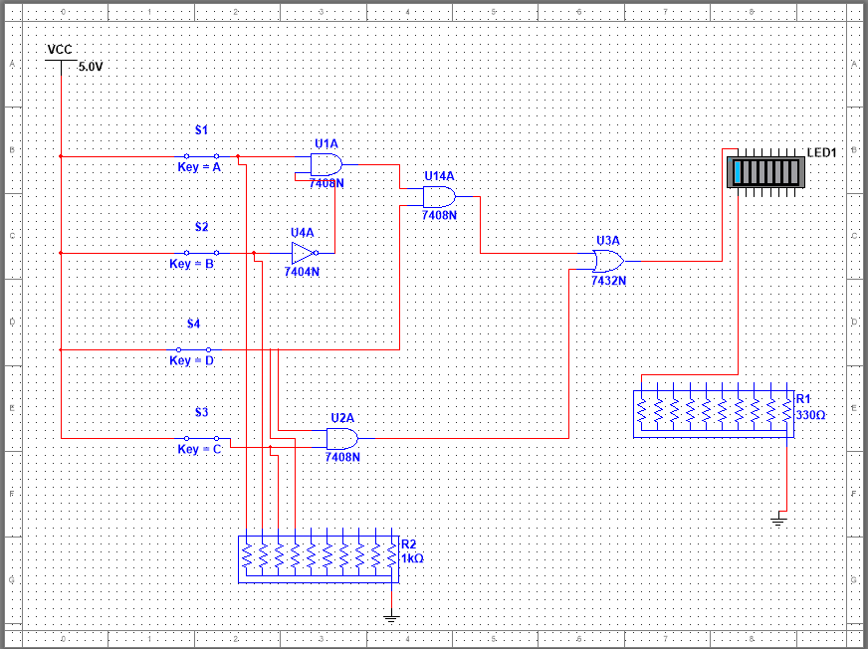

\*Input 1,1,1,1 and Output 1

Quartus Prime and Amani Board:

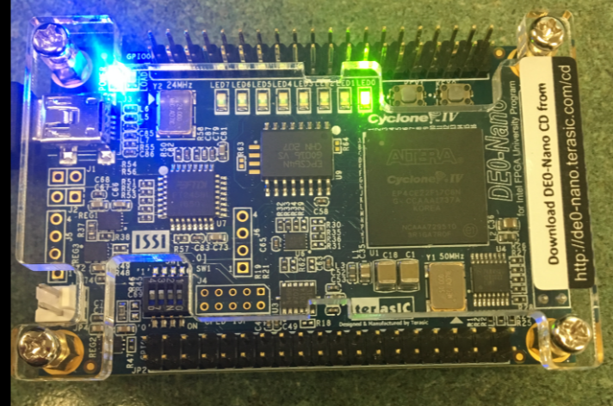

\*Input 1,1,1,1 and Output 1

Part 4:

In this part of the lab, I had to improve my reduction techniques by only being able to use the four IC’s to design the two functions derived from the truth table. The four IC’s were NAND, NOT, AND, and OR gates. The truth table was given to us and was used to derive its functions by using k-maps. After getting the two functions I had to create a schematic on Multisim combining the two functions together but still having two different outputs. Then I had to make sure that my Schematic followed the truth table. After verifying that the schematic was correct I used it as reference to create my Verilog code on Quartus Prime. Then I made sure my code compiled and successfully programmed onto my FPGA board. Finally, I made sure that my FPGA was giving me the correct output by using the truth table to check.

\*a detailed description of the Part 4 Design

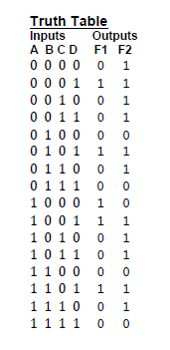 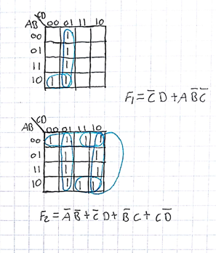

Verilog Code:

module Part4Design(in1, in2, in3, in4, out, out1);

input in1, in2, in3, in4;

output out, out1;

wire in1, in2, in3, in4, out, out1;

wire and1out, and2out, and3out, and4out, and5out, and6out;

wire or1out, or2out, or3out, orout4;

wire not1out, not2out, not3out, not4out;

not not1(not1out, in1);

not not2(not2out, in2);

not not3(not3out, in3);

not not4(not4out, in4);

and and1(and1out, not2out, not1out);

and and2(and2out, and3out, in1);

and and3(and3out, not2out, not3out);

and and4(and4out, not2out, in3);

and and5(and5out, not3out, in4);

and and6(and6out, not4out, in3);

or or1(out, orout1, and5out, and2out);

or or2(orout2, and1out, and4out);

or or3(out1, orout3, orout2, orout4);

or or4(orout4, and5out, and6out);

endmodule

Schematic Circuit Design:

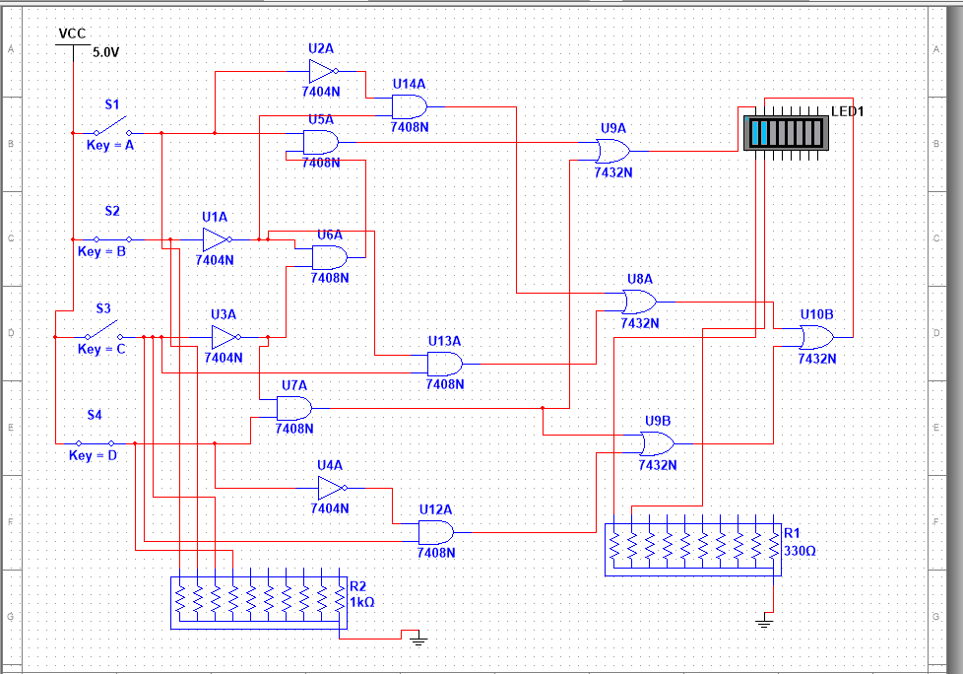

Quartus Prime and Amani Board:

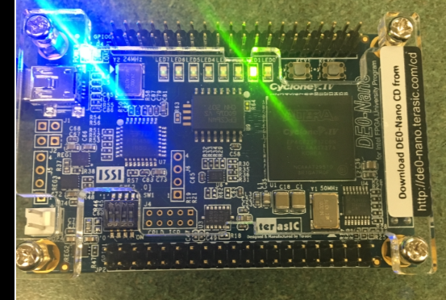

\*Input 1,0,1,1 and Output 0,1

Conclusion:

In this lab, I learned how to use the FPGA board and use Verilog. It was a little tricky to learn at first, but I was able to move forward and understand how the pins and outputs work as well as the code itself. I got to practice my truth tables and simplification and apply it to multiple parts of the lab. I was able to get all the simulated values to match up with the actual values. After this lab I discovered that you could buy a 7400 series TTL integrated circuit that has the same function as the EXCLUSIVE-OR gate, it is the 7486 Gate and I have included a picture and its truth table below. I also discovered that there is another way to create this gate with primitive and structural modeling. To do so you would have to use an AND, NAND, and OR gates. Although this is a different way to make the EXCLUSIVE-OR gate I don’t think that it is easier or necessarily better to use, since it would take up more gates. Below I have included a picture of the EXCLUSIVE-OR gate made a different way.

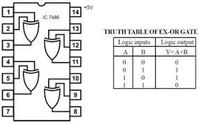

The EXCLUSIVE-OR gate can be made like this as well

